The Raine Study
Gen0/1_28 Breast Density (TiBs) Study

PHYSICAL ASSESSMENT
DNA blood: YES NO N/A
Name:______________________
ID number:__________________
DOB:_____\_____\_____
Mammogram: YES NO N/A
Most recent year___________________________
Location__________________________________
____________________________________________________________________________________
MEASUREMENTS
Height | Weight
Blood pressure | Hip/waist
TiBS | Medical Q
Breast DXA | DXA
CONSENT
Consent | YES | NO
DNA Blood consent | YES | NO | N/A
Blood sample collection | YES | NO | N/A
Medical Q coded by: _______ Date:____\____\____
Data Entered by: __________ Date:____\____\____
Data Checked by: _________ Date:____\____\____
PARTICPANT QUESTIONNAIRE
Online Completed Entered:____\____\____

Physical Completed Entered:____\____\____

ANTHROPOMORPHIC MEASURES RA:

Height (1):____________m (0.00) Height (2):__________m (0.00)

Weight: _____________ kg

Waist (1): _________cm Waist (2): _________cm

Hip (1): _________cm Hip (2): __________ cm
Comments:
BLOOD PRESSURE RA:
Time:_______ Arm cuff size:_______ Temp________

Min BP HR/Pulse
0. Sys_________ /Dia ________ ___________
2. Sys_________ /Dia ________ ___________
4. Sys_________ /Dia ________ ___________
6. Sys_________ / Dia________ ___________
8. Sys_________ / Dia________ ___________
10. Sys_________ / Dia________ ___________
TiBS ASSESSMENT

1. Areola Size (Diameter)

Left: _________ cm Right: _________cm

2. Scars □ No □ Yes- please specify

Approximate size: Width__________mm Length____________mm

3. Tattoos □ No □ Yes-please specify

Approximate size: Width ____________mm Length ____________mm

Mark on diagram below with and “X” the side and location (quadrant):
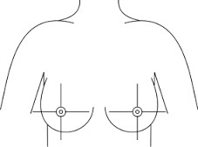
4. Piercings: Left No □ Yes □ Right: No □ Yes □

5. Please indicate your breast skin color on the diagram below:
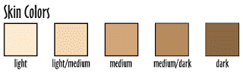
1 2 3 4 5

